**Liquid Marble Wallpaper in Grey and Gold**

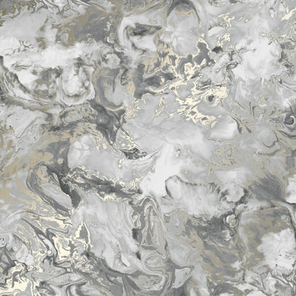Liquid marble wallpaper in grey and gold offers a stunning blend of elegance and luxury, making it a perfect choice for sophisticated interiors. The grey tones provide a serene and neutral backdrop, while the gold accents add a touch of opulence and warmth. The abstract, flowing patterns mimic the fluidity of real marble, creating a sense of movement and depth. This combination of subtle hues and metallic highlights makes it versatile, complementing both modern and classic decor styles. Ideal for living rooms, bedrooms, or feature walls, it transforms any space into a refined and inviting setting.